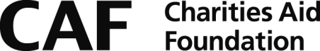

Transnational Giving Europe
Gift Aid Declaration

IMPORTANT Please complete in BLOCK CAPITALS.

Your completion and return of this declaration will enable CAF to recover tax on any payments you that you may make to Charities Aid Foundation (CAF) in the future.

Title: _____ Forename(s): ______________ Surname: ________________

Address : ____________________________________________________________
____________________________________________________________
____________________________________________________________
____________________________________________________________
Post Code :

I confirm I have paid or will pay an amount of income tax and/or capital gains tax for each tax year (6 April to 5 April) that is at least equal to the amount of tax that all charities or Community Amateur Sports Clubs (CASCs) that I donate to will reclaim on my gifts for that tax year. I understand that other taxes such as VAT and council tax do not qualify. I understand the charity will reclaim the 25p of tax paid on every £1 that I give from today onwards.

I confirm that I will advise CAF if this situation changes.

Signature :

Date:

Notes:

- If you pay tax at the higher rate you can claim further tax relief in your Self Assessment tax return.

- If you are unsure whether your donations qualify for Gift Aid tax relief, ask CAF. Or you can ask your local tax office for leaflet IR113 Gift Aid.

